PROCEEDINGS

October 19-20, 2017
Clearwater, FL

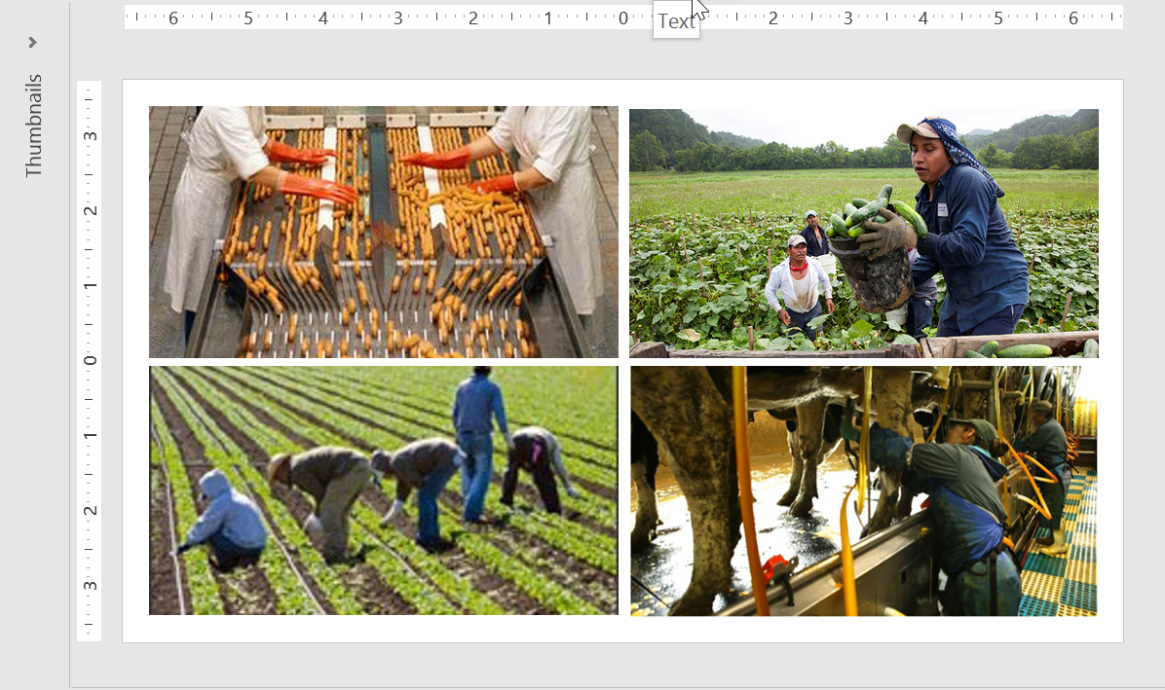
ACRONYMS USED IN THE REPORT

ADM Annual Directors’ Meeting
BMEI Binational Migrant Education Initiative
CAMP College Assistance Migrant Program
CIG Consortium Incentive Grant
CNA Comprehensive Needs Assessment
CSPR Consolidated State Performance Report
DACA Deferred Action for Childhood Arrivals
ECMHSP East Coast Migrant Head Start Program
ESL English as a Second Language
ESSA Every Student Succeeds Act of 2015
H-2A A Federal program allowing U.S. employers to bring foreign nationals to the U.S. to fill temporary agricultural jobs
GPRA Government and Performance Results Act
GPS Global Positioning System
HS High School
ICE Immigration and Customs Enforcement
ID&R Identification and Recruitment
IMEC Interstate Migrant Education Council
LEA Local Education Agency
MEP Migrant Education Program
MOU Memorandum of Understanding
MSIX Migrant Student Information Exchange
NPR National Public Radio
NRG Non-Regulatory Guidance
OME Office of Migrant Education
OSY Out-of-School Youth
PFS Priority for Services
Pre-K Pre-Kindergarten
SDP Service Delivery Plan
SEA State Education Agency

ACknowleDgements

The Interstate Migrant Education Council (IMEC) wishes to acknowledge the following individuals and agencies that have generously contributed their time and resources to making the national symposium The ABC’s of Education: Moving Forward Under ESSA to Engage the Agriculture, Business, and Education Communities, a success.
- Facilitators: Lead Facilitators – Ray Melecio (ESCORT); and Cari Semivan and Andrea Vázquez (META Associates); Table Facilitators: Susanna Bartee (KS), Jessica Castañeda (TN), Margot Di Salvo (ESCORT), Joan Geraci (NJ), Mary Haluska (AZ), Sue Henry (NE), Emily Hoffman (MA), Tracie Kalic (KS), Will Messier (LA), Mary Mulloy (VT), Sandy Peterson (ND), Antonio Ramos (OR), Jose Salinas (OH), and Brad Whitman (PA)
- IMEC Membership, Chair: Tomás Mejía (CO)
- ESCORT, Oneonta, New York – Kim Muller, Director
- Kansas Migrant Education Program, Doug Boline, Director and John Farrell, Special Projects Director
- Marty Jacobson, META Associates, Santa Fe, New Mexico (Photography and closing session PowerPoint presentation)
- John Fink, Atlanta, Georgia, (Program design and Symposium logo)
- Planning Committee comprised of Susan Durón, Director, META Associates; John Farrell, Kansas Special Projects Director; Francisco García, Executive Director, IMEC; Kim Muller, Director (ESCORT); and Nancy Wiehe, Senior Associate, IMEC
- Presenters: Matthew Blomstedt (Nebraska Commissioner of Education); Lisa Gillette (Office of Migrant Education, U.S. Department of Education, Washington, DC); Oscar Gonzáles (Policy and Outreach Specialist); Phillip Martin (University of California-Davis, Davis, CA); José Villa (ECMHSP); Chris Minnich (Council of Chief State School Officers, Washington, DC); Pedro A. Rivera (Secretary of Education, Pennsylvania Department of Education); and Claudio Sánchez (NPR)

This Proceedings document was prepared for IMEC by Dr. Susan Durón and Andrea Vázquez, META Associates, www.metaassociates.com – Final: March 22, 2018
TABLE OF CONTENTS

Acronyms Used in the Report
I. Executive Summary 1
II. Introduction 4
About the Interstate Migrant Education Council 4
Purpose of the Symposium and the Proceedings Document 4
Symposium Agenda 4
Organization of the Symposium Proceedings Document 5
III. Analysis of Discussion Trends 6
Implications of Worker/Farmworker Supply and Demand 6
Implications of Current Trends in the MEP 8
Implications of the Political Climate as We Move Forward Under ESSA 9
IV. Conclusions and Recommendations 11
V. Follow-up to the Symposium 14
VI. Appendices 15
Appendix A – Symposium Attendees 16
Appendix B – Symposium Agenda 26
Appendix C – Symposium Participants’ Comments & Recommendations…. 28


Executive Summary

The Interstate Migrant Education Council (IMEC) sponsored a national symposium, “The ABC’s of Education: Moving Forward Under ESSA to Engage the Agriculture, Business, and Education Communities”, on October 19-20, 2017 for 89 participants. The Symposium provided a forum for state and local education agency personnel, legislators, state school board members, university collaborators, and other Migrant Education Program (MEP) stakeholders to discuss new research, promising practices, and engaging information to benefit the MEP and the students and families we serve.

The Title I-Part C MEP is funded through the U.S. Department of Education to provide academic and supportive services to the children of families who migrate to find work in eligible activities (e.g., agriculture, fishing, dairy, processing plants). Funds support high quality education programs for migratory children to help ensure that the disparities among states in curriculum, graduation requirements, and academic standards are not a deterrent to student achievement and graduation. State education agencies (SEAs) allocate funds by formula based on per pupil expenditures for education and counts of eligible migratory children, ages 3 through 21, residing within the state. Inter- and intrastate coordination helps to cement this process.

Substantial trends have emerged from the symposium presentations and discussions that followed each session. Moving forward, these trends will have an impact on how migrant programs and services are delivered. The Every Student Succeeds Act (ESSA) provides the migrant community with an opportunity to rethink and reaffirm the purposes of the MEP and consider how best to meet the unique needs of migrant children and youth. The trends that emerged follow.

- There are major changes in immigration patterns that have occurred and are projected to continue across the U.S. as a result of the current political climate within the U.S. and in other countries. This issue points toward a need for staff development on immigrant migrant students’ cultural and language characteristics; and home, school, and community partners who speak their language and understand the culture.

- Mobility is decreasing although migrant work is available. Migrant families currently are not as mobile as a result of weather/natural disasters, political policies, and mechanization. This results in greater instances of migrant families that previously were eligible for the MEP to be living in poverty while children and youth do not now qualify for the MEP.

- States have reported that the number of pre-kindergarten (pre-K) migrant students and out-of-school youth (OSY) is increasing due to the new eligibility requirements under ESSA. Programs and materials are needed to serve this underserved population, along with cooperative relationships with existing service pre-K and OSY providers.

- An increase in workers who are in the U.S. on a temporary work visa (H2-A) typically are migrant-eligible males between the ages of 18 and 22. These youth need programs and strategies for OSY, including classes to prepare them to graduate high school and be college/career ready.

- Many states are experiencing a decrease in funding; thereby increasing the need to establish and expand collaborations to adequately serve the migrant student population and explore alternative fiscal and human resources to meet identified needs. Other states have an increase in funding and are experiencing the same need to reallocate resources and respond to service demands.

A summary of the recommendations made by workgroups during the symposium are presented below.

1. Explore opportunities under ESSA for the design and delivery of recruitment strategies that reach out to underserved populations such OSY and pre-K children. This demands a greater knowledge of school and community resources, closer connections with employers where migratory families work, greater flexibility in when and how identification and recruitment (ID&R) occurs, and training for new and veteran recruiters on changes in student eligibility requirements under ESSA.

2. Communicate with staff from the Office of Migrant Education (OME) to share the IMEC membership’s expert opinion on the development of non-regulatory guidance to address ESSA and the regulations to guide the design, development, implementation, and evaluation of MEPs.

3. Provide opportunities for professional learning about the MEP and the ESSA requirements. Ensure that each state provides learning and guidance about the MEP through professional development to state school officers, school superintendents, principals, instructional staff, and others who serve the needs of migratory children. Use techniques such as one-on-one technical assistance, mentoring, webinars, workshops, and local/regional/state/national meetings to provide a firm knowledge foundation.

4. Identify learning strategies and instructional techniques that take into account the diverse needs of migratory children and youth, many of which have experienced trauma, disruption, and discrimination on a daily basis. Consider students’ language, culture, and lifestyle in well-designed content that is comprehensible. Communicate with parents on ways to support their child’s education, including the distribution of home learning materials and resources for parents to use.

5. States should revisit their state MEP Comprehensive Needs Assessment (CNA) and Service Delivery Plans (SDP) as a result of changing migratory student demographics, ESSA requirements, and changes in funding and other local, state, and Federal resources received. Revise these documents, as needed, using the most recent program evaluation data and other migrant student outcomes and work with their broad-based CNA and SDP committees to reconsider how to use MEP funds most effectively.

6. Provide high quality academic and supportive services to benefit pre-K migrant children and their families to promote school readiness, to support school-aged migrant children, and to promote high school graduation and career and job readiness for secondary students and secondary-aged migrant OSY. Base the services designed on the most recent achievement and outcome data; evidence-based best practices; knowledge of state and local structures to support student success; availability of Federal, state, and local resources; and guidance on the use of MEP funds.

7. Collaborate with local, state, and Federal agencies, institutions of higher education, and the business/agri-businesses community to build and strengthen networks and ensure cultural competency in states. The migratory population has expanded to include immigrants and refugees from countries that previously did not receive services; thus, new learnings are needed about how best to identify, recruit, administer, and implement the programs and services for these diverse populations. Reaching out to potential partners in the community (e.g., parent leaders; refugee settlements, service organizations, faith-based organizations) is a rich source of information for schools.

The passage of ESSA has resulted in changes that will affect how migratory students are identified and recruited, how migrant funds and other resources are allocated, how programs are planned and delivered, how staff are prepared, and how collaborations are structured. Moving forward under ESSA requires strategic planning and engagement to realize this opportunity for meaningful collaboration among the agriculture, business, and education communities to benefit the migratory children and youth that we serve.

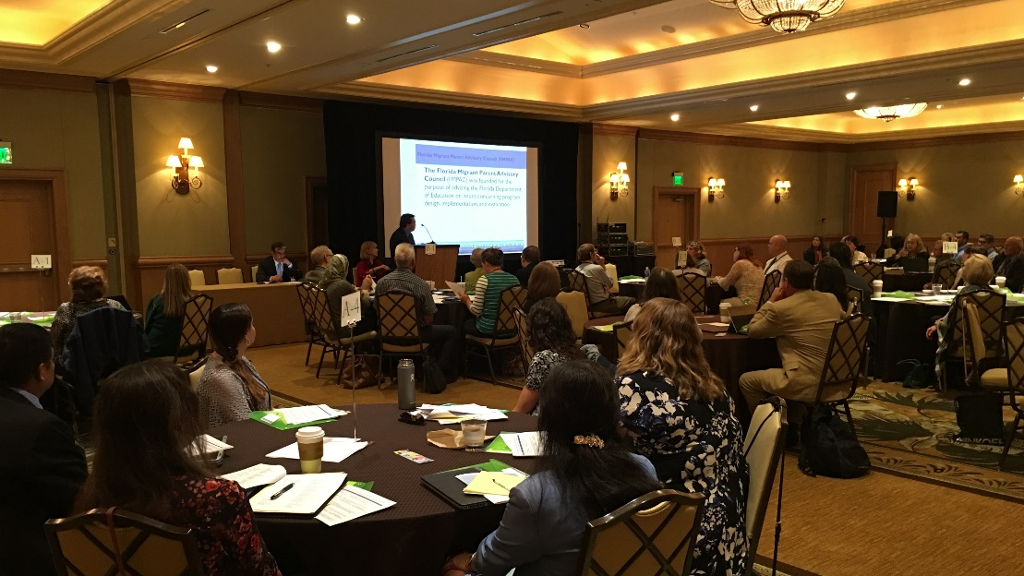


Introduction

About the Interstate Migrant Education Council
The Interstate Migrant Education Council (IMEC) was established nearly 35 years ago to advocate for the highest quality education and other support for the nation’s migratory children and youth. IMEC’s members are state-level decision makers who examine MEP policy issues related to coordination between public and private agencies, including all levels of government. Currently, there are 19 member states: Alaska, Arizona, Arkansas, California, Colorado, Hawaii, Illinois, Indiana, Kansas, Massachusetts, Nebraska, Nevada, New Jersey, New Mexico, New York, Ohio, Oregon, Pennsylvania, and Utah.

Purpose of the Symposium and the Proceedings Document
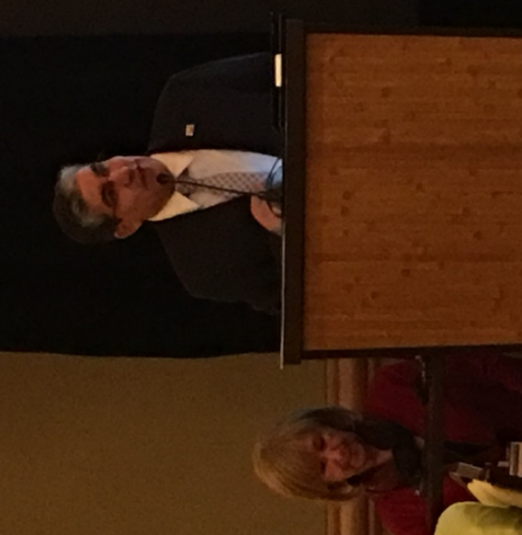
IMEC planned “The ABC’s of Education: Moving Forward Under ESSA to Engage the Agriculture, Business and Education Communities” to address the influence of ESSA on the MEP and explore meaningful ways to interact collaboratively to maximize our efforts. Due to the potential impact of these changes, IMEC posed questions to the Symposium participants—a broad represent-ation of migrant education program (MEP) decision makers—to stimulate discussion and respond to presentations made by national experts on worker/farmworker supply and demand, current MEP trends and programs, and legislation and state compliance with ESSA. Presenters and participants considered successful and promising practices and made recommendations in academic and support services, policies, and strategies. Statements from the discussion presented in Appendix A and the trends summarized in this document are presented to assist the MEP to design and provide the best possible services for migrant children and youth.

Symposium Agenda
Mr. Tomás Mejía, MEP director from Colorado and IMEC Chair; and Dr. Dinh Nguyen, Director of Title I, Part C in Florida—host state for the Symposium—opened the meeting and welcomed the participants. The first Core presentation was made by Dr. Phillip Martin, University of California-Davis, who provided an overview of the current supply and demand situation and how it impacts workers/farmworkers. A work group discussion guided by focus questions followed the session.

During a networking lunch, Mr. Claudio Sánchez of National Public Radio (NPR) briefed the audience on an NPR project he is working on that is related to migrant farmworkers. Next, Lisa Gillette, Acting Director of the Office of Migrant Education, U.S. Department of Education, provided comments on current trends in the MEP. This was followed by a second workgroup discussion addressing strategic focus questions.

Participants were then invited to three town hall discussions. During these discussions, participants had an opportunity to listen to talks given by three speakers: Mr. Óscar Gonzáles, a Policy and Outreach Specialist; Dr. José Villa of the East Coast Migrant Head Start Program (ECMHSP); and Mr. Claudio Sánchez of NPR. In each of these town hall meetings, participants asked questions and shared insights.

The second day opened with a welcome by Mr. Tomás Mejía, IMEC Chair who introduced Dr. Susan Durón, Director of META Associates to provide a summary of the Day 1 outcomes. The third Core presentation was provided by Mr. Chris Minnich, Executive Director of the Council of Chief State School Officers. This was followed by a superintendent’s panel facilitated by Mr. Minnich in which Dr. Matthew Blomstedt, Commissioner of Education for the State of Nebraska, and Mr. Pedro Rivera, Secretary of Education for the State of Pennsylvania addressed how their state and local policies and practices support the MEP and what the challenges are that states face. Following this final core presentation, a work group discussion addressed the related focus questions. Next, Francisco García, Executive Director of IMEC, provided a summary of key topics and next steps.

Mr. Tomás Mejía thanked the presenters and participants for their active participation and noted that a copy of the PowerPoint presentations delivered during the symposium Core sessions will be placed on the IMEC website at www.imec-migranted.org. A video of highlights from the two days of the symposium was shown to the audience.

Organization of the Symposium Proceedings Document
The table discussions after the Core Sessions were recorded by the three Lead Facilitators, Ray Melecio (ESCORT-Florida); Cari Semivan (META Associates); and Andrea Vázquez (META Associates) into nine total sets of notes. These notes were synthesized into a single cross-group summary that is included in the next section of this report along with an analysis of trends and recommendations. The source data is found in the Appendix. The final section of these Proceedings includes action items for decision makers and policymakers.

Throughout the report and appendices, quotes are found in text boxes that reflect the comments made by symposium participants; however, names are not included to ensure anonymity.


Analysis of Discussion Trends

Based on the core presentations and discussions, what are the implications of moving forward under ESSA to engage the agriculture, business, and education communities?

Implications of worker/farmworker supply and demand

- National trends reflect significant changes in migration and families moving. There are fewer traditional migrant farmworkers, consequently there are fewer families traveling for work resulting in fewer migrant students. This shortage of workers also is affecting what crops are being planted.
- There has been an increase in the number of H2-A workers. Many of the H2-A workers are individuals without children or those who travel without their children. The identification and recruitment of H2-A workers is more individualized than traditional recruiting, with “on the spot” interviews. Once identified, H2-A workers are difficult to serve since they are spread out geographically and often have needs different from typical school- or family-based recruiting.
- Weather and natural disasters have had an impact on work and migration. Depending on the incident and the area, they either could increase or decrease the number of workers/farmworkers identified in a state. For example, the State of Ohio saw an influx of families from Florida due to the floods that impacted Florida.
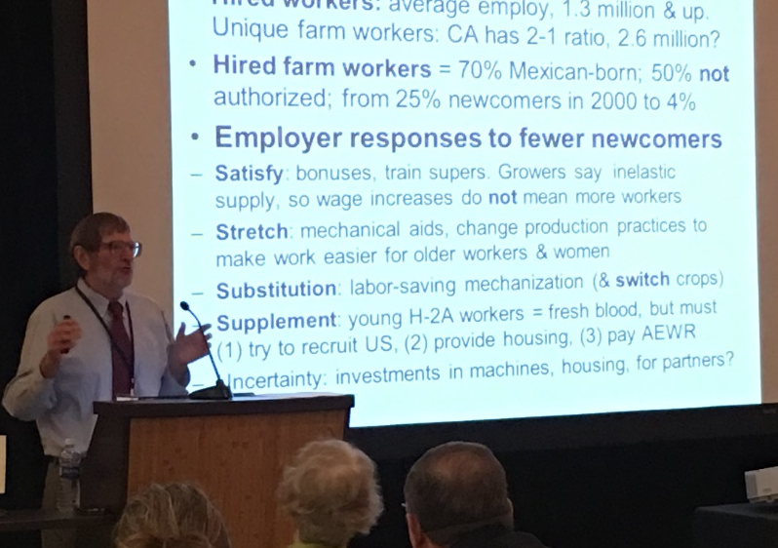
- Increases in refugees reflect the diversity of languages and cultures of eligible migratory students and families. States are seeing high concentrations of people from countries rarely served previously, such as Burma and various African countries. Consequently, schools with students from these countries may not have the resources in place to provide the support to meet their needs such as translators and interpreters, cultural liaisons, and professional development on working with linguistically- and culturally-diverse students. Some states are working to build relationships with the U.S. Department of Labor to address this issue and to marshal resources.
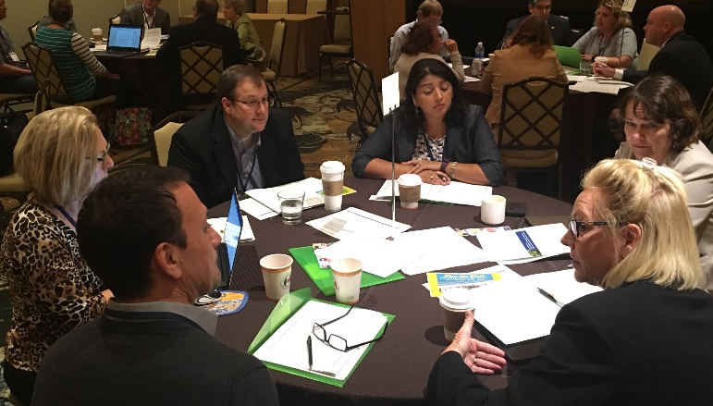
- Mechanization has greatly decreased the number of workers needed for crops in some states. While there remain negative implications of mechanization (e.g., expense, replacement parts, need for expert technicians to fix the machines, inefficiency, cost versus productivity), many states recognize the positive impact that mechanization has had on crops (e.g., aquaponics; machines/robots in dairies; weeding through drones/lasers; fish farms; tree-shaking machines; GPS use to plant straight crop rows; machines to thin beets, and pick blueberries, soy beans, cherries, and pears; computerized fruit maturation; new tracking tags for cattle).
- Science and genetics have increased crop production. For example, in the apple industry, many farmers are switching to a smaller root stock that will produce a new crop in five years versus 10 years. In New Mexico, some farmers are switching from chile peppers to pecans which require less water. Some farms also are moving towards organic farming.
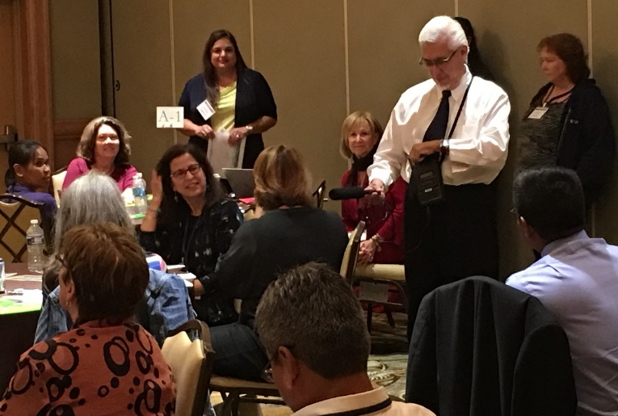
- Immigration has had a significant negative impact on the availability of farmworkers. Some families fearful of being deported are no longer migrating; therefore, fewer students are being identified and receiving needed services. Many families are not traveling their normal routes to avoid barricades. Additionally, the uncertainty of the Deferred Action for Childhood Arrivals (DACA) program has impacted college students, employers have a lowered trust of this population, and there is extreme anxiety among migratory workers. States report a need for fear-induced general counseling and one-on-one trauma counseling.
- Immigration issues and the current political climate also have had a positive impact on some migrant families. States report seeing more signing up for accredited high school (H.S.) diploma classes, citizenship classes, and English as a second language (ESL) services. There has also been an increase in the number of families wanting to establish themselves legally. The current political climate also has motivated some students to seek degrees and work to make a difference for the undocumented community.
Implications of current trends in the MEP

- Provide more information about interstate coordination; specifically, on how information sharing would and should work as it relates to the Migrant Student Information Exchange (MSIX).
- Increase communication with states and OME. An important role for OME should be to serve as a conduit for organizations and programs to work more closely together. Symposium participants would like information disseminated in a timely fashion. For example, while the regulations went into effect in July, updates to the ID&R manual were not made available until October, after the start of the school year.
- Review the Consortium Incentive Grant (CIG) process to encourage and increase CIG participation. Some states are interested in the possibility of having an option to join a CIG during its 2nd year of funding. Also, there were some Symposium participants who requested that CIGs be 4-year projects, rather than the current 3-year projects.
- Provide support from the national level around the Binational Migrant Education Initiative between the U.S. and Mexico to support eligible migrant students who cross international borders.
- Re-examine the re-interview process as re-interviews are very expensive and time consuming, regardless of whether they are completed by a consultant, LEA or SEA staff, or through recruiters from other states offering interstate coordination.
- Provide more guidance from OME on the Title I-C Government Performance and Results Act (GPRA), GPRA Leading Indicators, Priority for Services (PFS), eligibility, ID&R scenarios, and timeframes.
- In addition to information provided by OME at the Annual Directors’ Meeting (ADM), provide more support and technical assistance to new directors. The orientation and handbook for new project coordinators and state directors is useful; however, a refresher/update for veteran directors (i.e., similar to the directory provided by Title I-A) should be developed and distributed. Include sample documents to help staff understand how to complete forms, materials showing the connections among programs (e.g., McKinney Vento, Foster Care, Title I-A, Title I-C), and how to request technical assistance and mentoring programs for new state directors.
- Provide more technical assistance for ID&R and be proactive about clarification by providing more scenarios to work though eligibility issues. There also should be a guide for the re-interview process. States needs specifics about these requirements.
- Update the CNA, SDP, and Evaluation Toolkits. For example, since OME is requiring states to include a logic model, guidance on this topic should be contained in the Toolkits.
- Provide a collaborative partnership model through OME with other Federal programs (e.g., McKinney-Vento, Title I-A) and share the model with states. This also could include providing technical assistance and training to programs on how to legally “blend” programs to meet the needs of migrant students. Also, examples of how to establish a memorandum of understanding (MOU) between the different agencies would help solidify collaboration and the sharing of data.

Implications of the political climate as we move forward with services under ESSA

- One of the greatest impacts of ESSA on states will be related to funding since some states are receiving a smaller allocation and others a larger allocation. There is uncertainty about budget implications going forward and questions about how best to strategically use MEP funds. States reported difficulty in knowing how to plan future programs and services when the budget is unknown and unpredictable. Additionally, states will need to revise their CNAs and SDPs to reflect changes in funding, resources, and migratory student demographics. Collaboration with other programs is needed now more than ever.
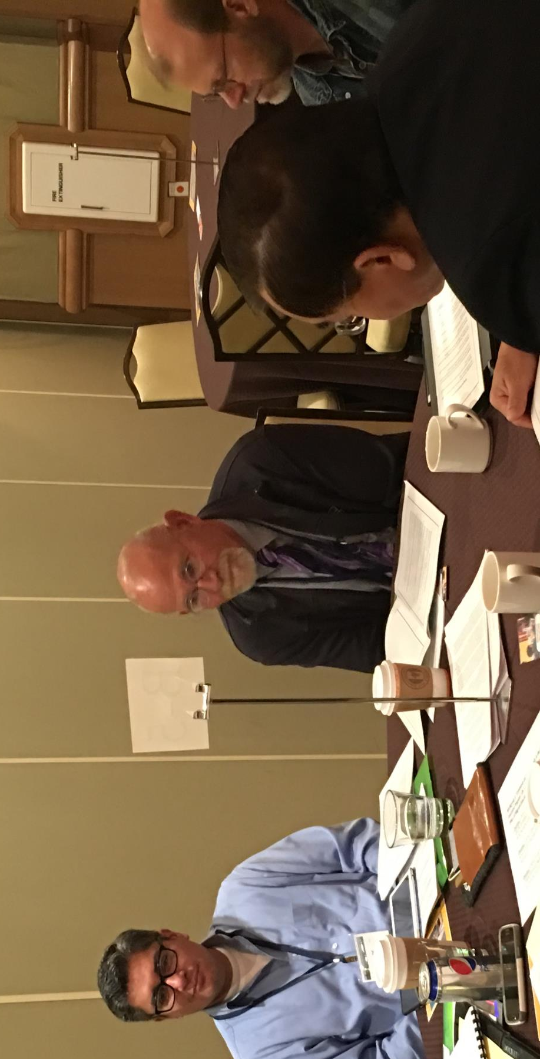
- For states with an increase in funding under ESSA, some service strategies that states are considering are hiring graduation specialists and parent engagement personnel to provide follow up and support, more summer programming after school classes, and targeted professional development. Likewise, for states with a decrease in funding resulting from ESSA, strategies that are being considered include providing services through regional versus local district projects, in-home versus site-based services, and collaborations with local community learning centers.
- ESSA has resulted in a significant impact on eligibility as more migratory students will become eligible based on expanded definitions. All of the changes in ID&R lead to a new kind of recruiting reflecting a need for new regulations, guidance, definitions, scenarios, and training materials.
- Under ESSA, there is more importance placed on the potential for increasing summer programming, before- and after-school services, and services for preschoolers and OSY— traditionally underserved populations. This constitutes a need to expand ID&R procedures beyond the in-school model which in some sites use as their primary ID&R model, revise statewide and local CNAs and SDPs, as well as restructure state MEPs across the nation.
- With the enactment of ESSA, there is an opportunity to provide flexibility in how services are designed and implemented. For this reason, building capacity to meet the needs of migrant children and families along with professional development on evidence-based strategies is imperative.
- Under ESSA, the changes in the definition of PFS will allow more states to identify more students designated as PFS because of summer moves. These changes will help local MEPs to identify those migrant children and youth having the greatest needs.
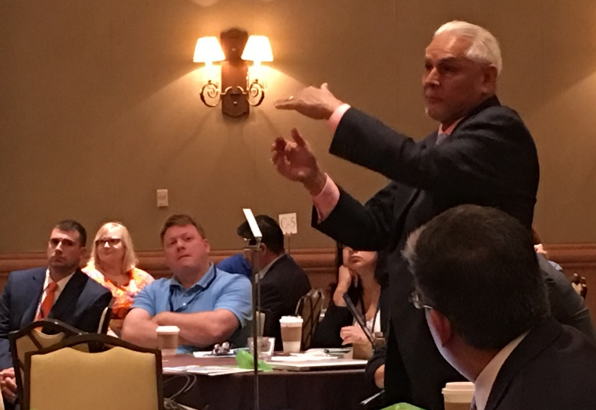
- Chief state school officers need to be informed about the MEP through conversations and open lines of communication among between OME and state MEPs. The Chiefs also need to lend support to collaboration and cross-training among projects serving migrant students in their states. Similarly, there is a need for staff from SEAs and LEAs to educate all local superintendents about the unique needs of migratory students.

Conclusions and Recommendations

The discussions that were held at the IMEC national symposium were followed by recommendations made by attendees for each of the topics identified. An analysis of the recommendations has resulted in the five cluster categories below. The recommendations, by category, are offered for consideration and implementation by local schools and school districts, SEAs, OME, and other MEP decision makers and policymakers.

1) Immigration/Migration Major shifts in immigration and migration patterns have Changes occurred and are projected to continue across the U.S.
More immigrant families who are eligible for the MEP are coming from countries other than Mexico and Central America, with an influx from African countries and Burma.
Recommendations: MEP staff at all levels need to share meaningful conversations with school/school district staff about who migratory students are (and are not), how they can qualify for the MEP, and ways to work collaboratively and efficiently to meet their needs. Some of the strategies mentioned by Symposium attendees include MOUs to solidify collaboration and data sharing, collaborative partnerships at the Federal level shared with states, utilizing funds from other Federal programs (e.g., Rural Schools, Homeless, 21st Century Community Centers), coordinating with immigrant support and refugee resettlement agencies, using culturally-competent instructional methods, and working together with parents and community leaders to understand how cultural characteristics may affect learning.

2) Decreased Mobility Changes in migration patterns have resulted from natural disasters and weather-related phenomenon, as well as the current political climate and crop/processing plant mechanization. These factors and increased automation of agribusinesses and farms leads to less migration.

Recommendations: Many children who formerly were eligible for the MEP continue to live an agricultural lifestyle in poverty but do not qualify for the MEP. Some of the strategies mentioned by Symposium attendees include expanding advocacy networks and collaborating with community, state, and government organizations on behalf of these former migrant students, offer more intense and/or more frequent MEP services to those students who are eligible, explore migrant patterns through Department of Agriculture data mapping to prepare for changes, communicate between sending and receiving states about student arrivals/departures, utilize MSIX, regularly update the migrant student profile in the CNA, and combine project and non-project funded services to reduce staff.

3) Increase in Pre-K and OSY Numbers of pre-K migrant children and OSY are increasing due to the new eligibility requirements under ESSA.
Recommendations: Avenues for networking and strategy sharing should be explored to build infrastructures to support pre-K and OSY through targeted ID&R, preschool services, services to OSY, and materials and training for MEP staff on these populations. Some of the strategies mentioned by Symposium attendees include professional development and cross-training, setting up state board of education goals for every child to be successful and for subgroups to improve their achievement, conduct in-home MEP services working with parents and children together, connect with health clinics to provide services to migratory students, train recruiters to look for new populations, and conduct shared recruiting along state borders.

4) Increase in H2-A Workers There has been an increase in migratory youth, who typically are male and traveling without their family, and are in the U.S. on a temporary work visa (H2-A).
Recommendations: Provide mentoring and classes to prepare this migrant population to set learning objectives, survive and thrive in the communities in which they reside, and graduate from H.S. and explore postsecondary, career, and workplace options. Some of the strategies mentioned by Symposium attendees include providing avenues to support migrant families and students emotionally; offering recruiter training that focuses on hard-to-reach H2-A workers; and providing supportive services and referrals to agencies in the community to assist with housing, transportation, counseling, and other basic needs.

5) Changes in Title I-C Funding Under ESSA, shifts are occurring in the Title I-C allocation to states. Many are seeing a decrease, some an increase.
Recommendations: Some of the strategies mentioned by Symposium attendees to address the changes in Title I-C funding include ensuring that MEP service delivery is aligned with state priorities; establishing a statewide MEP advisory group that includes local superintendents to inform them about MEP requirements and obtain their support; examining the mission and strategic plan of each MEP service collaborator to determine who best can provide the service, thus avoiding duplication; increasing summer (Category 2) programming, after school services, and credit recovery; considering if some of the work that is contracted out can be done inhouse, relying on the services available through CIGs to provide ID&R and quality control more efficiently, providing reading and OSY lessons using electronic means, and developing strategies for identifying and serving pre-K and OSY populations.

During the facilitated discussion after the OME session, participants shared questions and recommendations for consideration by OME—some very specific and others more general in nature. The comments, questions, and recommendations are found in Appendix C, Question 2. Briefly, attendees requested guidance from OME on definitions and non-regulatory guidance (NRG); specificity on ID&R issues; changes to the CIG structure; technical assistance and support to SEA MEP staff; the establishment of communication structures for sharing information; updates to the CNA and SDP toolkits; and sample documents/materials, directories, and handbooks to support new and veteran MEP staff.

The programmatic changes under ESSA, shifts in migratory student demographics, and changes in state Title I-Part C funding precipitate a re-examination of MEP services provided by states as articulated in the state CNAs and SDPs. States are charged with looking closely at migratory students’ achievement and outcome data to determine needs, prioritize services for students with PFS, plan and implement evidence-based services and strategies, and design and evaluate the MEP services to ensure that they are aligned with student needs and state priorities. This continuous improvement cycle is especially needed as we go forward under ESSA to implement the requirements for MEP student eligibility and the provision of high quality services.


Follow-up to the Symposium

The focus questions and discussion prompts used by facilitators to guide discussion called for comments on next steps as the audience moved through the group process. The IMEC membership will be considering the information contained in this report as it continues its role of leadership on advocacy and the gathering of information to aid policy makers.

This Proceedings document was presented to the general membership during the January 2018 meeting and again at subsequent meetings to encourage discussion and determine further action to be taken related to the discussion notes, emerging trends, conclusions, and recommendations. IMEC will post the Proceedings on its website and share this document with OME as it continues to develop non-regulatory guidance to support ESSA.

To follow up the symposium, a committee or work group of IMEC members or their designees should be convened to consider policy implications for SEAs, LEAs and avenues to work with OME to jointly address action items. Shared timelines, responsibilities, and deliverables should be developed.

For information or follow-up with the Symposium presenters, consult the websites below.

- Dr. Matthew Blomstedt, Nebraska Commissioner of Education
https://www.education.ne.gov/

- Ms. Lisa Gillette, OME, U.S. Department of Education
https://www2.ed.gov/programs/mep/index.html

- Mr. Óscar Gonzáles, Policy and Outreach Consultant
oscargonzalesjr@hotmail.com

- Dr. Phillip Martin, University of California-Davis
http://migration.ucdavis.edu

- Mr. Chris Minnich, Council of Chief State School Officers (CCSSO)
https://www.ccsso.org/

- Secretary Pedro A. Rivera, Pennsylvania Department of Education
http://www.education.pa.gov/Pages/default.aspx

- Mr. Claudio Sánchez, National Public Radio
https://www.npr.org/people/2101122/claudio-sanchez

- Dr. José Villa, East Coast Migrant Head Start Project
http://www.ecmhsp.org/


Appendices

Appendix A – Symposium Attendees
Appendix B – Symposium Agenda
Appendix C – Symposium Participants Comments and Recommendations
- Discussion and Recommendations: Question 1
- Discussion and Recommendations: Question 2
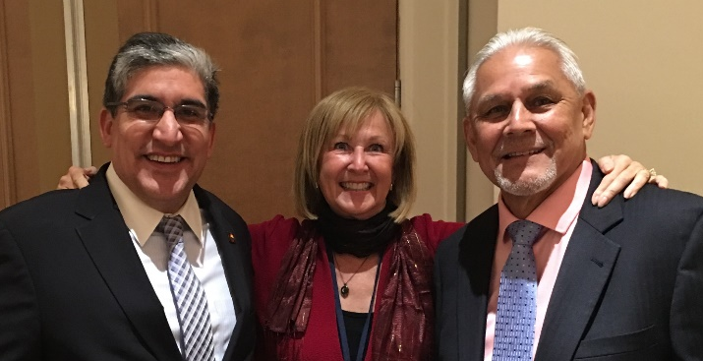
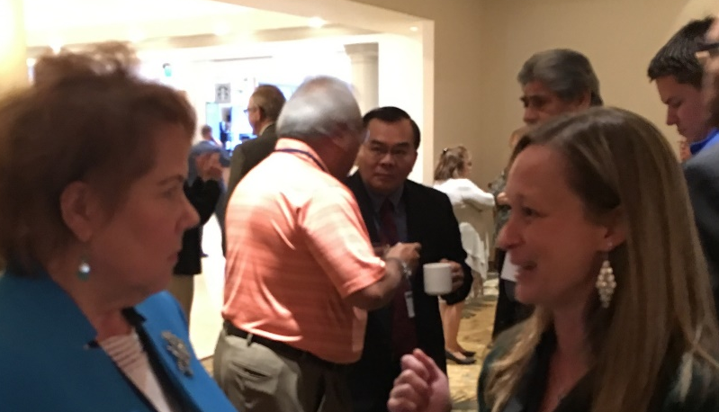
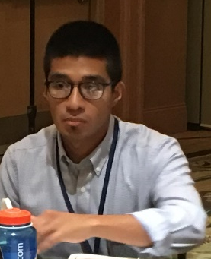

- Discussion and Recommendations: Question 3

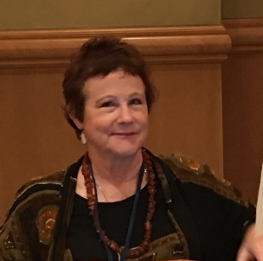

APPENDIX A


2017 Symposium Particiants

Amas Aduviri
Director, CAMP Program
Oregon State University
337 Waldo Hall
Corvallis, OR 97331
amas.aduviri@oregonstate.edu
541-737-3923

Veronica Aguila
Migrant/Title III Director
California Department of Education
1430 N. Street
Sacramento, CA 95814
vaguila@cde.ca.gov
916-319-0578

Jennifer Almeda
State Coordinator, Migrant Education Program
South Carolina Department of Education
1429 Senate Street
504-C
Columbia, SC 29201
jmalmeda@ed.sc.gov
803-734-8219

Bree Ausenbaugh
Migrant Education Specialist
Indiana Department of Education
500 Earlywood Drive
Franklin, IN 46131
bausenbaugh@ecesc.k12.in.us
317-234-6868

Kulwadee Axtell
Education Programs Professional
Nevada Department of Education
700 E. Fifth Street
Carson City, NV 89701
kaxtell@doe.nv.gov
775-687-9256

Guillermo Barriga
Project Manager
Metro Migrant Education Program
14707 E 2nd Ave
Suite 180
Aurora, CO 80011
gbarriga@aps.k12.co.us
720-810-6700

Susanna Bartee
Administrative Communications
Graduation, Outcomes and Services for Out-of-School Youth
27105 Webster Court
Weston, MO 64098 susannabartee@gmail.com
816-808-4777

Valerie Beard
Assistant Director of English Learner and Migrant Education Programs
Indiana Department of Education
115 W Washington St/South Tower, Ste. 600
Indianapolis, IN 46204
vbeard@doe.in.gov
(317)797-0946

Rachel Beech
Consultant
Kansas State Department of Education
900 Sw Jackson St. Rm 600
Topeka, KS 66612-1220
rbeech@ksde.org
785-296-8965

Joyce Bishop
Coordinator for OSY Migrant
Alabama Department of Education
112 Cochran Lane
Albertville, AL 35391
joyce.bishop1@gmail.com
256-264-5662

Matthew Blomstedt
Commissioner of Education
Nebraska Department of Education
301 Centennial Mall South
P.O. Box 94987
Lincoln, NE 68508-2529
matt.blomstedt@nebraska.gov
402-471-5020

Doug Boline
Director, Migrant Education Program
Kansas State Department of Education
Jackson Street, Suite 600
Topeka, KS 66612
dboline@ksde.org
785-296-2600

Elia Bruggeman
Special Assistant to the Commissioner
Minnesota Department of Education
1500 Highway 36 West
Roseville, MN 55113
elia.bruggeman@state.mn.us
303-582-8440

Judy Bueckert
Executive Director
SIEC Region 4 Migrant Education Center
1102 Tree Lane Drive
Jasper, IN 47456
jbueckert@siec.k12.in.us
812-482-6641

Angel Casiano
Director of Program Operations West
East Coast Migrant Head Start Project
3700 DMG Dr.
Lakeland, FL 33811
acasiano@ecmhsp.org
863-229-7100 (1332)

Jessica Castaneda
Web/Education Consultant
4660 Hills Creek Road
McMinnville, TN 37110
sparkedinnovations@gmail.com
931-668-4129

Patrick Chapman
Federal Programs Executive Director
Colorado Department of Education
1560 Broadway, Suite 1100
Denver, CO 80202
chapman_patrick@cde.state.co.us
303-866-6780

Christine Cowen
Migrant Education Specialist
Massachusetts Department of Elementary and Secondary Education
75 Pleasant Street
Malden, MA 02148
ccowen@doe.mass.edu
781-338-6301

Angie Cruz
Assistant Director of English Learners and Migrant Education Programs
Federal State and Competitive Grants
Collier County Public Schools
5775 Osceola Trail
Naples, FL 34109
Cruza1@collierschools.com
239-377-4578

Cindy DeRosa
Program Advisor
Arkansas Department of Education
Four Capitol Mall
Little Rock, AR 72201
cindy.derosa@arkansas.gov
501-324-9663

Margarita DiSalvo
Education Specialist
ESCORT10006 N. Dale Marby
Suite 102
Tampa, FL 33618
margot.disalvo@escmail.org
813-401-8885

Kelly Dolan
MEP in-school youth Coordinator
Vermont Migrant Education Program
UVM Extension
327 US Route 302, Suite 1
Barre, VT 05641
kelly.dolan@uvm.edu
802-476-2003 (208)

John Doll
Member, Kansas State Senate
2927 Cliff Place
Garden City, KS 67846
johndoll22@gmail.com
620-275-9304

Susan Durón
Consultant
META Associates
518 Old Santa Fe Trail, Suite I-208
Santa Fe, NM 87505
duron1@aol.com
303-550-3333

Sarah Emmal
Director, Migrant Education Program
Alaska Department of Education and Early Development
801 W 10Th St Ste 200
Po Box 110500
Juneau, AK 99801-1878
sarah.emmal@alaska.gov
907- 465-3286

John Farrell
KS MEP Director of Special Projects
Eudora USD #491
1310 Winchester Road, P.O. Box 490
Eudora, KS 66025
johnfarrell@eudoraschools.org
913-940-3769

Kim Fioramanti
Services Coordinator
Florida Migrant Interstate Program
165 Sunset Terrace
Lake Placid, FL 33852
Kim.fioramanti@heartlanded.org
863-840-5035

Jonathan Fernow
State Migrant Education Program Coordinator
Oregon Department of Education
255 Capitol Street, NE
Salem, OR 97310
jonathan.fernow@state.or.us
503-947-5807

Francisco García
Executive Director
Interstate Migrant Education Council
1 Massachusetts Ave NW
Suite 700
Washington, DC 20001
fcgarcia@q.com
571-225-4901

Betty García Mathewson
Project Director
Migrant Technical Assistance Support Center
Research Foundation of SUNY –
The College at Brockport
350 New Campus Drive
Brockport, NY 14420
gmathews@brockport.edu
585-395-5138

Cipriano Garza
101 N.E. 19th Street
Homestead, FL 33030
garza1234@gmail.com
786-521-6699

Joan Geraci
Director of Special Projects
Gloucester County Special Services
GCSSSD Special Projects
1340 Tanyard Road
Sewell, NJ 08080
jgeraci@gcecnj.org
856-468-6530 (1053)

Lisa Gillette
Group Leader
United States Department of Education
Office of Migrant Education
400 Maryland Avenue
Washington, DC 20202
lisa.gillette@ed.gov
202-260-1426

Óscar Gonzáles
Policy and Outreach Consultant
1107 5th Street
Davis, CA 95616
oscargonzalesjr@hotmail.com
323-270-6652

Mary Ellen Good
Director of Federal Programs
Centennial BOCES
2020 Clubhouse Drive
Greeley, CO 80634
meg@cboces.org
970-352-7404 (1110)

Adrian Gutiérrez
Oregon Migrant Education Service Center
2611 Pringle Road, SE
Salem, OR 97302
adrian.gutierrez@wesd.org
503-385-4710

Mary Haluska
State Director, Migrant Education Program
Arizona Department of Education
1535 W. Jefferson Street
Phoenix, AZ 85007
Mary.Haluska@azed.gov
602-542-5169

Patricia Hayes
Regent Emeritus, the University of Colorado
12575 E. Bates Circle
Aurora, CO 80014
patricia.hayes@cu.edu
303-809-2683

Anthony Hearn
Migrant Education Supervisor
New Jersey Department of Education
100 Riverview Plaza, 2nd Floor, CN 500
Trenton, NJ 08625
anthony.hearn@doe.state.nj.us
609-633-2492
Sue Henry
Migrant Education Program Director
Nebraska Department of Education
301 Centennial Mall South, Box 94987
Lincoln, NE 68509
sue.henry@nebraska.gov
402-471-3440

Rasha Hetata
State Director of Migrant Education
Office of Federal Programs, Center for Accountability and Continuous Improvement
25 South Front Street, Mail Stop 404
Columbus, OH 43215
rasha.hetata@education.ohio.gov
614-752-1469

Emily Hoffman
Migrant State Program Director
EDCO Collaborative
36 Middlesex Turnpike
Bedford, MA 01730
ehoffman@edcollab.org
339-222-5607

Marty Jacobson
Consultant
META Associates
518 Old Santa Fe Trail, Suite I-208
Santa Fe, NM 87505
marty@meta1.us
406-855-2594

Alysia Johnston
President
Fort Scott Community College
2108 S. Horton Street
Fort Scott, KS 66701
alysiaj@fortscott.edu
620-223-2700 (5200)

Tracie Kalic
Director, Graduation, Outcomes and Services for Out-of-School Youth
Fort Scott Community College
17899 Sunset Drive
Weston, MO 64098
tkalic@embargmail.com
785-249-9219

Solomon Kaulukukui
Director, Migrant Education Program
Hawaii State Department of Education
475 22nd Avenue, Room 126
Honolulu, HI 96816
Solomon_Jr._Kaulukukui/SSB/HIDOE@notes.k12.hi.us
808-305-9856

Flavia Mansberger
Manager, Elementary and Secondary Education Act Program
Federal State and Competitive Grants
Collier County Public Schools
616 South 5th Street
Immokalee, FL 34142
mansbelf@collierschools.com
239-377-0571

P.L. Martin
Professor Emeritus
University of California, Davis
1 Shields Avenue, 2101 SSH
Davis, CA 95616
martin@primal.ucdavis.edu

Esmeralda Martínez
Migrant Director
Southwest Region
1424 2nd Street
Adams State University
Alamosa, CO 81101
etmartinez@adams.edu
719-480-1015

Michael Maye
Director
Identification Rapid Response Consortium
53 Mary St.
Auburn, NY 13021
mmaye2929@gmail.com
845-588-5115

Carmen Medina
Division Chief
Pennsylvania Department of Educaiton
333 Market Street, 5TH Floor
Harrisburg, PA 17126-0333
cmedina@pa.gov
717-783-6466

Tomás Mejía
Director, Migrant Education Program
Colorado Department of Education
1560 Broadway St., Suite 1450
Denver, CO 80202
mejia_t@cde.state.co.us
303-866-6592

Ray Melecio
Assistant Director
ESCORT/Research Foundation
10006 North Dale Mabry Hwy
Suite 102
Tampa, FL 33618
ray.melecio@escmail.org
813-963-6677

Will Messier
Director ID&R MIS2000-MSIX
100 Saratoga Village Blvd.Suite 41
Ballston Spa, NY 12020
wmessier@nycap.rr.com
518-289-5618

Chris Minnich
Executive Director
Council of Chief State School Officers
One Massachusetts Avenue, NW, Suite 700
Washington, DC 20001-1431
chris.minnich@ccsso.org
202-336-7015

Nakita Mongar
Education AssociateII
Alaska Department of Education and Early Development
801 W 10th StreetP.O. Box 110500
Juneau, AK 99811
nakita.mongar@alaska.gov
907-854-8222

Amanda Mosher
Data Specialist
State of Alaska Department of Education & Early Development
PO Box 110500
Juneau, AK 99811
amanda.mosher@alaska.gov
907-465-2885

Kim Muller
Director
ESCORT
300 Bugbee Hall, SUNY Oneonta
Oneonta, NY 13820
kim.muller@escmail.org
800-451-8058

Mary Mulloy
Director of Migrant Education
Vermont State Department of Education
219 North Main Street, Suite 402
Barre, VT 05641
Mary.Mulloy@vermont.gov
802-479-1226

Christina Nava
Director
Idaho Department of Education
650 W State St
Po Box 83720
Boise, ID 83702-5936
cnava@sde.idaho.gov
208-332-6876

Dinh Nguyen
Director of Title I, Part C
Florida Department of Education
325 West Gaines Street
Tallahassee, FL 32399
dinh.nguyen@fldoe.org
850-245-0811

Chris Norton
Director
Geneseo Migrant Center
3 Mount Morris-Leicester Road
Leicester, NY 14481
cnorton@gvboces.org
585-658-7975

Jeff Ojeda
Ed Specialist
Utah State Board of Education
250 East 500 South
Salt Lake city, UT 84114
jeff.ojeda@schools.utah.gov
801-538-7945

Barbara Patch
State Director of Migrant Education
New Hamsphire Department of Education
State Office Park South
101 Pleasant Street
Concord, NH 03301
barbara.patch@doe.nh.gov
603-271-2273

Andy Pederson
IT Manager
East Coast Migrant Head Start Project
2700 Wycliff Road, Suite 302
Raleigh, NC 27607
apederson@ecmhsp.org
919-926-3328

Brenda Pessin
Director of Migrant Education Services
Illinois Migrant Council
118 S. Clinton Street, Suite 500
Chicago, IL 60661
brenda_pessin@msn.com
312-663-1522 (233)

Sandy Peterson
Program Administrator, Department of Public Instruction
North Dakota Department of Public Instruction
600 East Boulevard Avenue, Dept 201
Bismarck, ND 58505
smpeterson@nd.gov
701-328-2170

Karen Qualls
Director
Northeast Arkansas Migrant Education Cooperative
103 West Park
Bald Knob, AR 72010
karen.qualls@baldknobschools.org
501-724-6227

Jennifer Quick
KS MEP/GOSOSY Fiscal Agent
Fort Scott Community College
2108 Horton Street
Fort Scott, KS 66701
jenniferq@fortscott.edu
620-768-2908 (21)

Lauren Radin
MEP Secondary Consultant
Colorado Department of Education
Colorado Department of Education1560 Broadway, Suite 1100
Denver, CO 80202
radin_l@cde.state.co.us
303-866-6753

Antonio Ramos de Jesús, Director
Oregon Migrant Education Service Center
2611 Pringle Road, SE
Salem, OR 97302
antonio.ramos@wesd.org
503-989-3500

José Reyes-Lua
Statewide Migrant Education Recruitment Coordinator
Center for Schools & Communities
275 Grandview Avenue, Suite 200
Camp Hill, PA 17011
jreyes-lua@csc.csiu.org
717-224-1413

Pedro Rivera
Secretary of Education
Pennsylvania Department of Education
333 Market Street
Harrisburg, PA 17126
parivera@pa.gov
717-783-9780

Beth Robinson
Principal Consultant
Illinois State Board of Education Division of English Language Learning
100 W. Randolph St, 14-300
Chicago, IL 60601
berobins@isbe.net
312-814-3519

Gloria Rodríquez
Sr. Associate - ELL Specialist
Public Consulting Group
707 Sierra Vista Road
Corrales, NM 87048
gloriarodr@yahoo.com
571-594-1668

Monica Romero
Director of Federal Programs
Chandler Unified School District
500 W. Galveston
Chandler, AZ 85225
romero.monica@cusd80.com
480-224-3771

Christina Rutland
Migrant Education Program Director
New Mexico Public Education Department
120 S. Federal Place, Room 206
Santa Fe, NM 87501
christina.rutland1@state.nm.us
505-827-3706

José Salinas
Director
Ohio Migrant Education Center
428 1/2 Croghan St.
Freemont, OH 43420
jsalinas@nwoesc.org
419-332-6007

Claudio Sánchez
Correspondent, Education, National Desk
National Public Radio
1111 N Capitol St. NE
Washington, DC 20002
CSanchez@npr.org

Cari Semivan
Consultant
META Associates
9620 S. Dover Way
Littleton, CO 80127
cari@meta1.us
720-339-5349

Gerald Stefhon
Associate Manager
Public Consulting Group
4312 Cholla Drive, NE
Rio Rancho, NM 87144
gstefhon@pcgus.com
864-421-3925

Andrea Vázquez
Consultant
META Associates
518 Old Santa Fe Trail, Suite I-208
Santa Fe, NM 87505
andrea@meta1.us
512-573-7206

José Villa
Chief Executive Officer
East Coast Migrant Head Start Program
2700 Wycliff Road, Suite 302
Raleigh, NC 27607
jvilla@ecmhsp.org
919-420-0334

Patricia Weissenberg
Coordinator, Migrant Education Program
Somerton Elementary School District #11
343 N. Carlisie Avenue
P.O. Box 3200Somerton, AZ 85350
pweiss@ssd11.org
928-341-6027

Brad Whitman
Supervisor of School Improvement Services
The Northwest Tri-County Intermediate Unit
252 Waterford Street
Edinboro, PA 16412
brad_whitman@iu5.org
814-734-8449

Nancy Wiehe
Sr. Project Associate
Interstate Migrant Education Council
One Massachusetts Avenue
Suite 700
Washington, DC 20001
Nancyw@ccsso.org
202-336-7078

Nathan Williamson
Director of Title Grants and Support
Indiana Department of Education
115 West Washington Street 600 South
Indianapolis, IN 46204
nwilliamson@doe.in.gov
317- 232-6671

Benjamin Zink
Education Specialist
Nebraska Department of Education
301 Centennial Mall South
Lincoln, NE 68509
benjamin.zink@nebraska.gov
402-471-2740

Courtney Zmach
Director, Research, Evaluation and Grant Development
Federal, State and Competitive Grants
Collier County Public Schools
5775 Oscola Trail
Naples, FL 34109
zmach@collierschools.com
239-373-3581

This page left blank intentionally

APPENDIX B – Symposium Program

APPENDIX C
Symposium Participants’ Comments and Recommendations
1 – DISCUSSION SUMMARY AND RECOMMENDATIONS

Based on the “Overview of Worker/Farmworker Supply and Demand” presentation by Dr. Phillip Martin, what are the implications?

What does the future hold for migratory workers and crops? What are you seeing in your states?
- The natural disasters are having an affect nationwide. We are seeing migrations patterns because of the fires and hurricanes. Some people have lost their jobs due to damaged trees/crops and housing, so workers/families are moving to where the crops are.
“Farming and farmworkers are not going away. There are many OSY, but there are still many families. These families are becoming more stable where they live.”
- There is an increase in the need and number of H2-A workers and a decrease in the number of traditional migrant farmworkers. Additionally, H2-A workers tend to be older and do not qualify for the MEP.
- There has been a significant increase in the refugee population. This includes people coming from Asia, Africa, and Central and South America. Staff report that they are seeing over 120 different languages and this makes it difficult for all aspects of the MEP.
- Students stay in schools longer in order to finish the year and/or program (i.e., graduate).
- ESSA is making it necessary to put more identification and recruitment efforts in other areas previously ignored. For example, mill workers in Oregon now qualify.
- Some states are seeing more seasonal OSY recently and they are harder to serve.
- There is a concern in many states about how mechanization will affect numbers.
- The immigration climate is keeping workers more hesitant. Cranberry was affected by mechanization starting several years ago.
- Small farms are merging into large farms.
- Real estate value is premium in some areas of the country so some farmers are selling their farmland.
In Minnesota, they have established a Sister Cities initiative with Cuernavaca. We have been working with the Mexican consulate and the Governors of Morelos and Minnesota to make sure families are being taken care of when they return to Mexico. DREAMers that return to Mexico from Minnesota will receive free tuition and housing to continue their education.
- As marijuana legalization expands across the country, growers are abandoning traditional agricultural crops for this crop which is not a qualifying work for Title I-C.
- The political environment around anti-immigrant policies is impacting the migration patterns throughout the U.S. Also, families are returning to their native countries due to immigration issues.
- Urban areas are seeing an increase in the cost of living which is causing families to move to communities where housing is more reasonable.
- Many states are reporting more Immigration and Customs Enforcement (ICE) agents which causes fear among the migrant community. This means fewer people are willing to move.
- Some states are reporting issues of water and water rights. This is prohibiting some farmers from being able to plant crops.

What do the data show in terms of the trends in the mechanization of farm work? What crops are showing the biggest impact of mechanization and what companies in your state are working on future mechanization?
- States report that mechanization is being used on many crops. This includes strawberries, apples, pears, almonds, blueberries, snap beans, green beans, lettuce, tobacco, potato, etc. Mechanization is also being used in dairy farms, dairy processing, meat processing, poultry processing, etc.
- Many states recognize the positive impact that mechanization has had on crops. Aquaponics is increasing crop production. Global Positioning System (GPS) is used to plant straight crop rows. Machines are used to thin crops such as beets and lettuce.
“Fortunately, we have many row crops and no machine will ever be able to catch a chicken.”
- Genetics are being used to change the size of trees to enable the use of machines to shake the trees; reducing the height of the trees makes it easier to use machines for picking.
- The market dictates the crops. For example, more kale is being grown, especially for restaurants. Kale is a crop that uses mechanization for thinning. On the other hand, more “boutique” apples, such as Honeycrisp and Gala, are being grown. These varieties of apples do not respond well to mechanization, while Red Delicious and Granny Smith do.
- The number of workers needed for crops in some states has greatly decreased. When machines are used, farmers are finding out that replacement parts are difficult to find and many growers are needing knowledgeable technicians that can fix the machines.
“In Oregon, an ultrasound machine is used to determine when cattle are ready for slaughter. They can tell by looking at the 13-14th rib and calculating the fat content of the cow to determine the grade of the meat. Only 155 people who work in the U.S. use this machine.”
- Several states reported that there are some crops that just cannot be worked with machines. For example, many orchards that have tried different kinds of machines for picking peaches, apples, and cherries have found that the machines bruise the fruit.

How have recent immigration issues and the political climate impacted the availability of farm workers?
- Families have anxiety and a heightened level of fear due to the current political climate. Consequently, this leads to less parent and family participation and creates barriers to provide the services and supports to our migrant population. Families report being fearful of being deported which results in fewer participating in the program, fewer being identified, and fewer receiving needed services.
- Trauma counseling, and counseling in general, is now needed more by families due to fear. Mental health is a big need. The MEP supports parents by holding parent institutes and meetings, workshops, and trainings from agencies. The MEP collaborates with other agencies to access health providers.
The climate of immigration is making it more difficult to build relationships with families in order for them to trust recruiters and complete the eligibility interview process to determine MEP eligibility.”
- Families are not traveling their normal routes due to fear of ICE. Families now are reluctant to open their doors to recruiters and people that they do not know.
- School districts are working with parents in completing an informational form so the district is aware of who will take care of the children in case the parent/parents are picked up by ICE while the children are in school.
- Schools must look at issues of guardianship. Parents are saying they would give up their children to allow them to stay here if they were deported. They feel it is better for their children to be in the foster care system here than to go back with them in Mexico. Some children would have to become the family breadwinner if parents are deported.
- The uncertainty of the DACA program has impacted college attendees. The workforce has lowered the trust of this population; and with less trust, there is extreme anxiety among these youth.
- Immigration has nearly stopped the migration of farmworkers from other countries.
“Families don’t want to be signed up on a COE even though our state is pretty friendly to migrant communities. Many families are saying they should do something besides migrant work. They want to be invisible.”
- In New Mexico, the school climate has shifted. Parent interviews have shared difficult stories such as students being told to go back to Mexico, when in fact they are U.S. citizens. People are making racist comments. The political climate has shifted the climate of schools. There are now more direct, overt issues with racism--it is not hidden anymore.
- In Nebraska, the current political climate has manufactured outrage by people thinking that jobs are being taken. Small towns in Nebraska have been revitalized because of immigration. Small towns are changing with an influx of immigrants; the first wave is often met with “what are we going to do,” yet now towns have shifted and welcomed them.

2 – DISCUSSION SUMMARY AND rECOMMENDATIONS

Based on the “Comments on Current Trends in the Migrant Education Program” presentation by Ms. Lisa Gillette, Office of Migrant Education, what are the implications

What additional questions do you have for the OME after hearing the presentation?

- Continue to support the positive outcomes of the MEP across the nation.
- Provide more support at the national level for binational migrant students and the Binational Migrant Education Initiative (BMEI).
- Develop and disseminate more guidance on the ID&R re-interview process to ensure that it is realistic for states to complete.
- Define “dropout”, “previous year”, and “service”.
- Define Algebra I completion – 1 semester or 2 semesters (1 year)?
- Increase the time for “engaging in work” to 90 days to allow for refugee student processes and when natural disasters impact farm work.
“With Congress, they want to know how much bang for the buck they get. Migrant student numbers are down and when you looking at how kids are performing in reading and math, the kids did not do well compared to all students. But we feel that if we didn’t have the MEP, that these children would not be served and be ‘forgotten kids’.”
- Allow additional states to join CIGs within the first 3 months of grant award.
- Be a conduit for Federal programs and organizations to work together to support migrant students and families.
- Help change the perception of the migrant population.
- Look at other ways to determine the student count.
- Provide more information on the National Implementation Study.
- Offer more eligibility scenarios and information/training.
- Sometimes it takes longer than 60 days for refugee students or students affected by natural disasters to be eligible for farmworker jobs. Increase from 60 days to 90 days to engage in work.
- OME can be a conduit for organizations and programs to work more closely together. Aside from having a presentation at the ADM, provide more support at the national level.
- In thinking about the future, transportation funding would be helpful. Half of the budget is on transportation. We need more ways to support this. This then helps the whole population of the school. It is about equity and access.
- Re-interviews are very expensive and time consuming whether you do it with a consultant or via interstate coordination. Can how to simplify the requirements be re-thought?
- We would like further clarification from the non-regulatory guidance. Question H12 refers to “qualifying move” while the statute uses the language “migratory agricultural move within 36 months.” For example, a student’s eligibility expires in Vermont on 12/15/18 based on their most recent qualifying move and they move to New York on 11/25/17. If the MAW is 10/15/14, would the student qualify in New York if all other eligibility criteria are met?
- What are the implications for funding and the College Assistance Migrant Program?
- What is a service? It could be a support service. How do we count services? How are we coding services? We realize that the comments in the Consolidated State Performance Report (CSPR) about changes are important. We need to dig into the reasons.
- What is the background information on why PFS changed? It is the rare exception to have a migrant student not at academic risk/PFS. Why distinguish which kids are PFS when they all are?
- How can information be disseminated in a timelier fashion? For example, the regulations went into effect in July and updates to the ID&R manual are just coming out. Overall, OME does a good job, but states need more timely updates in regard to ESSA changes.
- We would like more information about how intrastate coordination (sharing of information – referring to MSIX) would/should work. Those moves are not always to districts that have migrant programs and therefore access to MSIX.
- When will the new indicators for the GPRAs be required? What do we do with the old GPRAs since states are required to report on them (dropout and graduation rate)? Who sets the targets for the GPRAs?
- States have not been uniformly collecting data on Leading Indicators data. How will this be monitored?

What technical assistance would be helpful for OME to provide to the field?

- Update the SDP and CNA Toolkits to include new information.
- Provide guidance around data collection on GPRAs (e.g., promotion to next grade: what does this mean in some states? Do you count credits? Attendance?).
Our group appreciates that students that drop out are a new priority in Title I-C migrant education. This needs to be pushed harder so that states begin to address this priority.
- Provide guidance on the re-interview process; to include ways to simplify/eliminate steps.
- Share sample documents that help staff understand how to complete or work with a particular form.
- Reduce the CSPR data burden.
- Share how can states receive support to use MSIX more effectively.
- Regarding the Logic Model, share what OME like states to do with it and clarify what practical use it has. We need information on knowing the end product and understanding the process/narrowing the scope.
- Title 1-A has a directory on areas of expertise in terms of ways to get help, particularly for new state directors. We would like to see something like this developed by staff in states who have a high level of expertise.
- Provide more guidance in addition to information provided at the Annual Directors Meeting (ADM) through technical assistance to new directors. The orientation/handbook for new project coordinators and state directors is useful. A refresher/update for veteran directors (i.e., similar to the Title I-A directory) should be prepared and distributed that includes sample documents to help staff understand how to complete specific forms, materials showing the connections among programs (e.g., McKinney Vento, Foster Care, Title I-A, Title I-C). Technical assistance in the form of a mentoring program for new state directors should be instituted.
- Provide more assistance to states working on being compliant.
- Update the MSIX User’s Manual.
- Update the Non-Regulatory Guidance for the entire MEP.
- Offer clarification/technical assistance on “blending” funds between programs and ideas for collaboration with other programs.

What can states do to coordinate with other Federal programs such as Rural Education, Title I-A, and Homeless Education?

- Develop a collaborative partnership model at the Federal level and share with states. Include other programming eligibility on COE, split-funded staff positions, utilize Rural Schools money for broadband/Smart Boards, collaboration among staff from different programs, joint trainings, etc. Include Title III and 21st Century to the list of programs with whom the MEP should be collaborating.
“We have monthly meetings within the SEA share mission statements and program goals to allow increased awareness at the LEA level. We encourage this to happen at the federal level.”
- Collaboration among SEA staff from different programs on a regular basis.
- Establish agreements (MOUs) between the different agencies to solidify collaboration and ensure shared data.
- We need to make sure that we plan our services so that we are not in competition with any other services.

3 – DiSCUSSION SUMMARY AND RECOMMENDATIONS

Based on the STATE EDUCATION AGENCY PANEL, what should migrant education look like given the impact of legislation and States’ compliance with ESSA?

What is the impact of ESSA on the MEP?

- It will greatly reduce our funding. We need to rework our CNA and SDP to take into account the reduced funding. We think this should happen to make funding more in line with student numbers, but it will be a challenge.
- In Colorado, we expect budget to go down 10%. We are looking to create one Colorado MEP by combining services offered and having regions travel because costs will be lower.
“In Pennsylvania, we are seeing a new category of eligible worker – lumber. We will have to re-train recruiters to visit new communities and locations and then we will need to create a new location for services.”
- With ID&R changes, the door to a new kind of recruiting is open.
- We are keeping an eye on the 60-day waiting period because work is not always available when families arrive. Our families only work the one crop (lettuce) and for some reason they don’t work in other available crops.
- If we are thinking globally, the change of the definition will increase the number of students within the program.
- We think the PFS changes will make it easier to identify PFS.
- PFS has an impact through our state funding formula. For services, we have the same standard for all our kids because we have the money to serve all of them.
- We think we will have a larger number of PFS because we had a lot of summer movement, but we had a hard time documenting regular term interruption even though we believe interruption was taking place.
- Building capacity and professional development is imperative.
- As we add more recruiters, we need more funds to pay for training and quality control. This results in needing to be more creative with providing services with the remainder of the funds while still maintaining focus on outcomes.
“Migratory and homeless kids were taken out of the accountability system. Seems that in some states, ESSA plan has just reinforced the silos.”
- More students will be eligible for services because of qualifying moves (no ag/fishing work) which will extend eligibility for longer periods of time and increase the child count.
- Focus on summer programming to increase Category 2 numbers. More importance placed on summer programming and services for preschoolers and OSY.
- Summer services, early childhood services, and services to OSY are extremely important under ESSA.
- We do not feel it is a negative change, but has made states take a step back and review all the ID&R materials to ensure that they meet the new law and guidance.
- The tightening of the definitions on sought and recent past history will have an impact, but we won’t really know until we get further into the process.
- ESSA relates much more to equity. ESSA has allowed for equity to rise to the surface on what every school system.

What strategies are states planning to implement to provide quality services with the increase or decrease in funding resulting from ESSA?

- There will be changes resulting from new funding formulas (e.g., regional programs funded instead of individual programs, increasing number of regions/migrant programs, cross-training staff to perform multiple roles within the program, increasing carryover, more summer programming, more use of technology to reduce costs).
- Collaboration with other programs and service providers.
“Collaboration is key (Migrant Health, Migrant Head Start, etc.); we can’t afford to do all we did before.”
- Collaborators to focus on the needs of students versus the needs of adults (wanting to look at issues of students versus people wanting to access funds).
- ID&R, OSY, non-project services may be combined to reduce staff.
- Professional development of staff.
- Look at what each potential service provider or group can bring to the table to determine services based on actual student needs and focus on what each person or entity needs.
- Focus on credit recovery. For example, one state asked students to pay for the PASS packet. If the student completed it, they were reimbursed.
- Staff will have multiple roles through enhanced cross-training strategies.
- States may strive to increase the number of services in the summer to receive Category 2 funding.
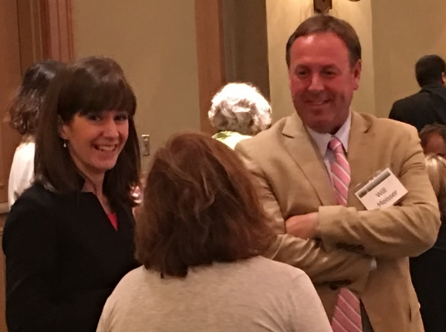
- In Illinois, there is an increase in recruiters’ urgency. Recruiters are looking for new populations and hoping to do shared recruiting along state borders.
- States will be having a bigger focus on best practices for schools and all populations.
- States are connecting more with other programs like pre-k programs and health clinics that can provide services to the migrant students versus using migrant funds to deliver those services.
- Some states are not using contractors as much and doing more re-interviews and other in-activities inhouse.
- Rely on the services available through Consortium Incentive Grants (e.g., ID&R quality control, reading curriculum, OSY lessons, pre-K collaboration strategies).

What are the kinds of collaborations that can occur among state superintendents to promote the MEP?

- State superintendents supporting cross training among projects serving migrant students, and collaborative relationships among the different projects.
“If a clear understanding of the permissible use of funds is in place, collaboration may result more readily between state-level programs.”
- Training to state and local superintendents on the MEP, migrant student eligibility, and services that can be provided.
- Service delivery planning aligned with the state vision.
- State superintendents set the culture at the state level for services to migrant students.
- Educate state and local superintendents about who are migrant students and what their needs are; promote migrant students and share their success stories.
- Provide emotional support for migrant families and students.
- State board goals are for every child to be successful, subgroups need to improve their achievement, and service delivery planning needs to align with the state vision.
- State superintendents support and facilitate cross-program collaboration and training (i.e. a McKinney Vento school liaison should have knowledge of migrant child eligibility).
“You would think that if they drive by the farms and orchards that they would know they have migrant students, but often there is high turnover is local leadership, and they don’t always know about migrant students who can be invisible in the community.”
- A statewide advisory group with the local superintendents and have them know the requirements.
- Statewide data shared with all districts so that they can work together to reach academic benchmarks.
- Train the LEA superintendents/principals/on the recruitment part of migrant.
- In Pennsylvania MEP staff are trained to deliver the message in schools. 200+ ESL teachers were invited to the state MEP conference, besides MEP staff.

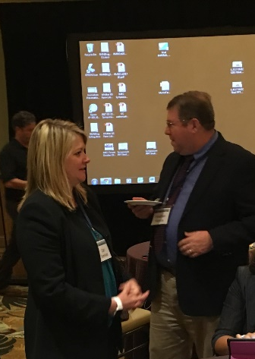
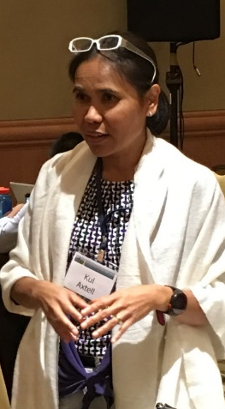
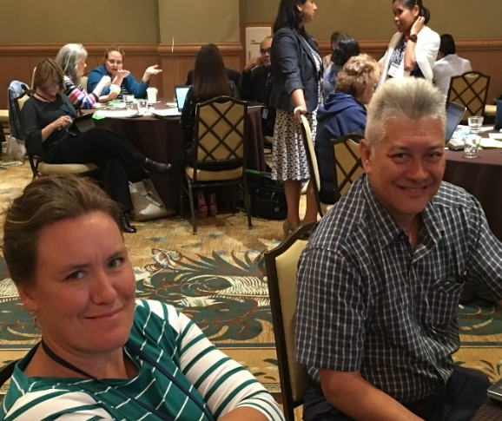
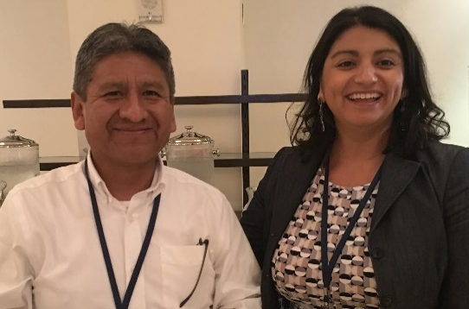
- While it requires a lot of legwork, what has been effective in Massachusetts is to conduct road trips across the state to educate other agencies about the MEP.


